|  |  |  |  |
| --- | --- | --- | --- |
|  | Bansilal Ramnath Agarwal Charitable Trust's  Vishwakarma Institute of Information Technology  **Department of**  **Artificial Intelligence and Data Science** | | |
| Student Name: **Siddhesh Dilip Khairnar** | | | |
| Class: **SY** | Division: **B** | | Roll No:**272028** |
| Semester: **III** | | Academic Year:**2022-23** | |
| Subject Name & Code: **DBMS, ADUA21204** | | | |
| Title of Assignment: **Design at least 10 SQL queries for suitable database application using SQL DML statements: All types of Joins, Sub-Query and View.** | | | |
| Date of Performance: **26-09-2022** | | Date of Submission: **30-09-2022** | |

# Aim: Design at least 10 SQL queries for suitable database application using SQL DML statements: all types of Joins, Sub-Query and View.

**Problem Statement**:   
1. Create table Teaching_Faculty_information containing attributes such as (Faculty_id, Faculty_name, Dept_name) and Subject_information containing attributes such as (Subject_id,Subject_name,Faculty_id) perform below mentioned operations of joins   
Inner join  
  
left join  
Right join   
Full join  
Cross Join  
  
2. Create Student table (sid,sname,marks) and execute Sub-Query to calculate second highest marks   
  
3. Create view on Student table (sid,sname,marks) for marks > 60  
  
4. Perform the operation to create Index, Sequence, Synonym by taking suitable example

**Background Information**: A join clause is used to combine rows from two or more tables, based on a related column between them. A MySQL sub-query is a query nested within another query such as Select, Insert, Update, Delete, etc.

**Software Requirements**: MYSQL Shell

# The Handwritten Write-Up:

# 

# 

# Results or Experimentation:

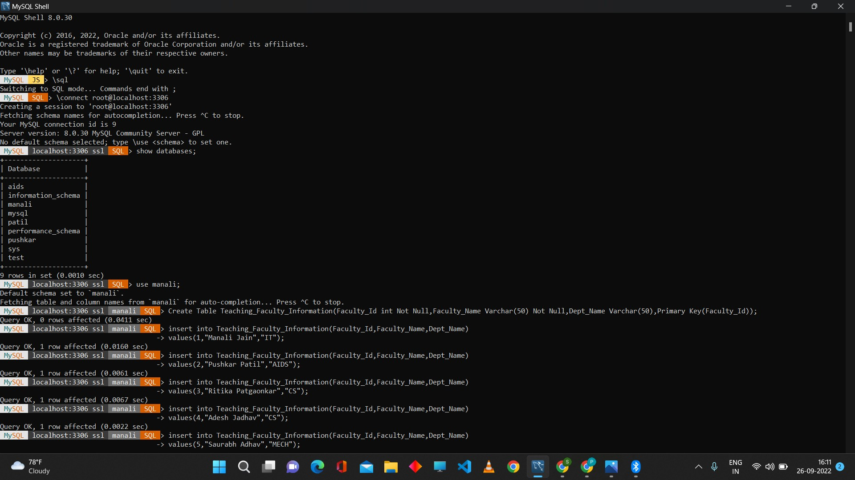

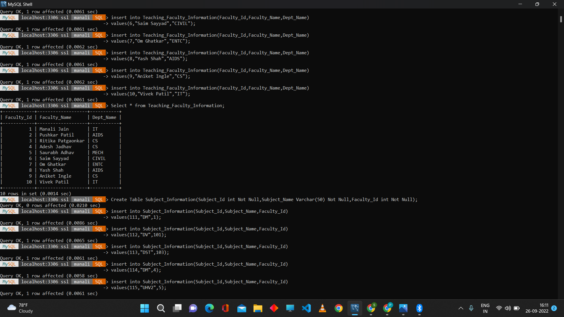

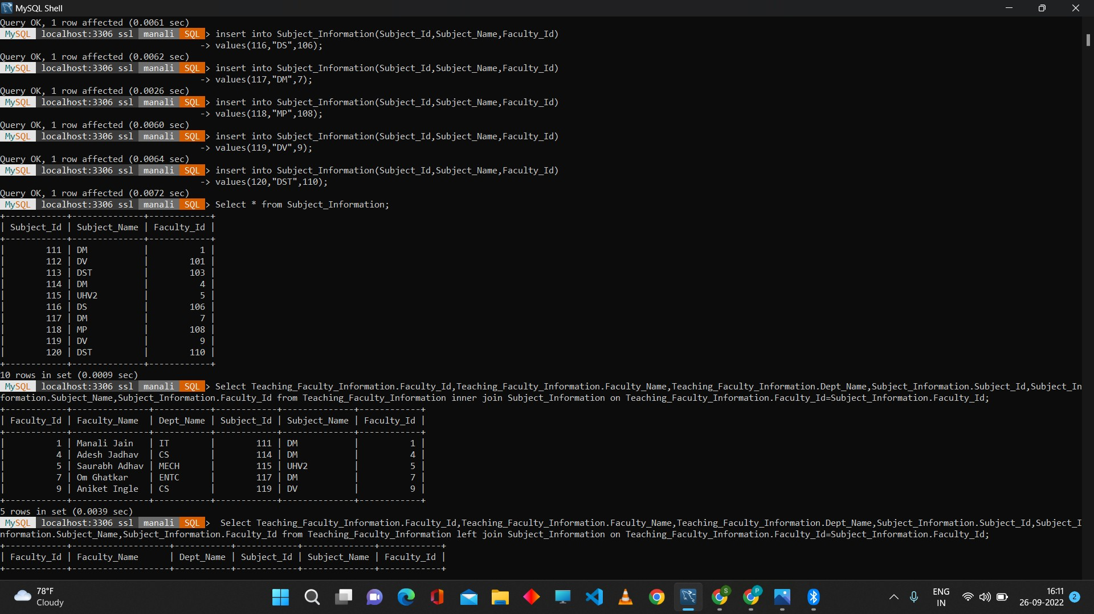

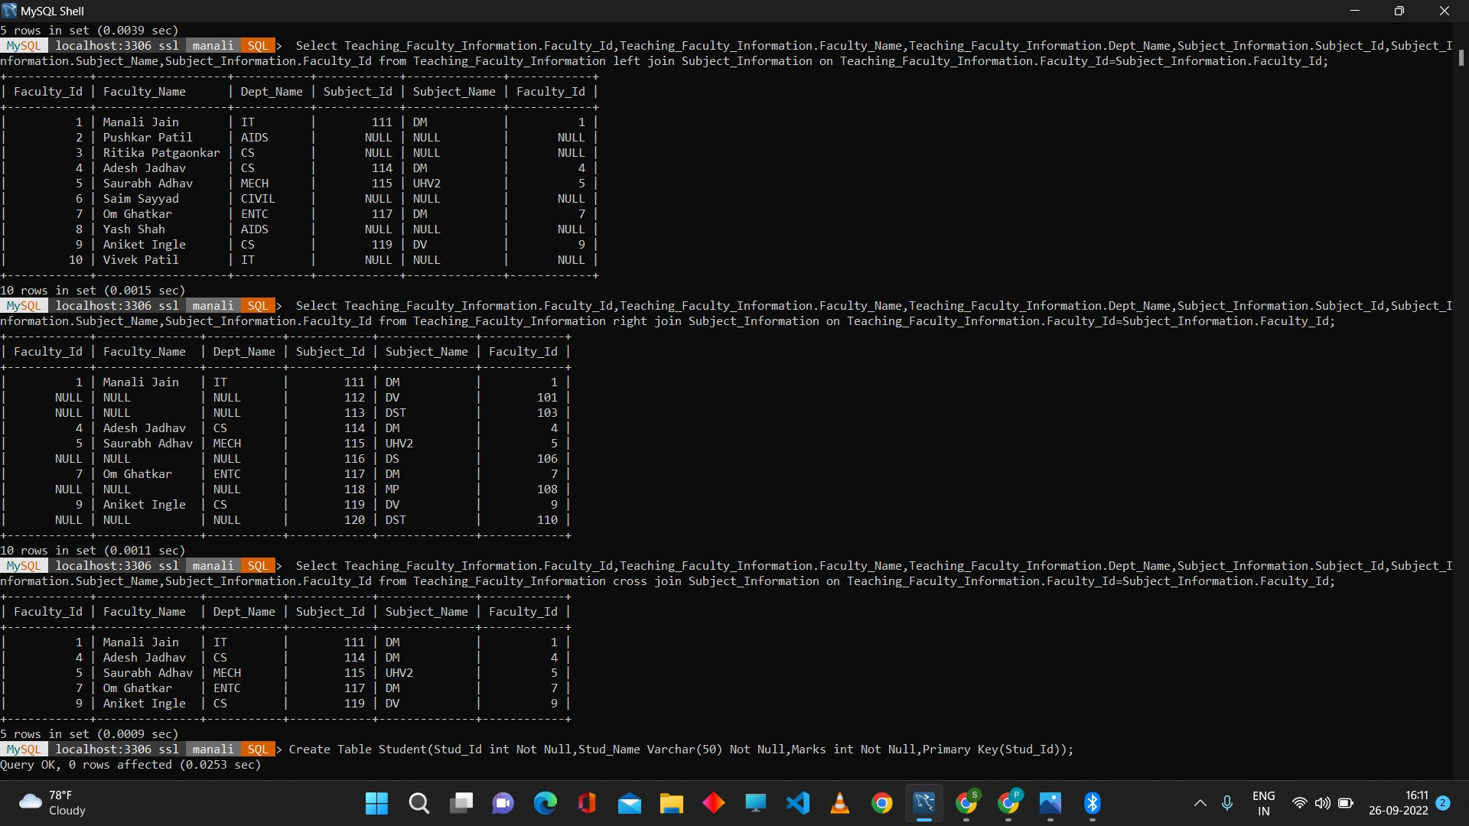

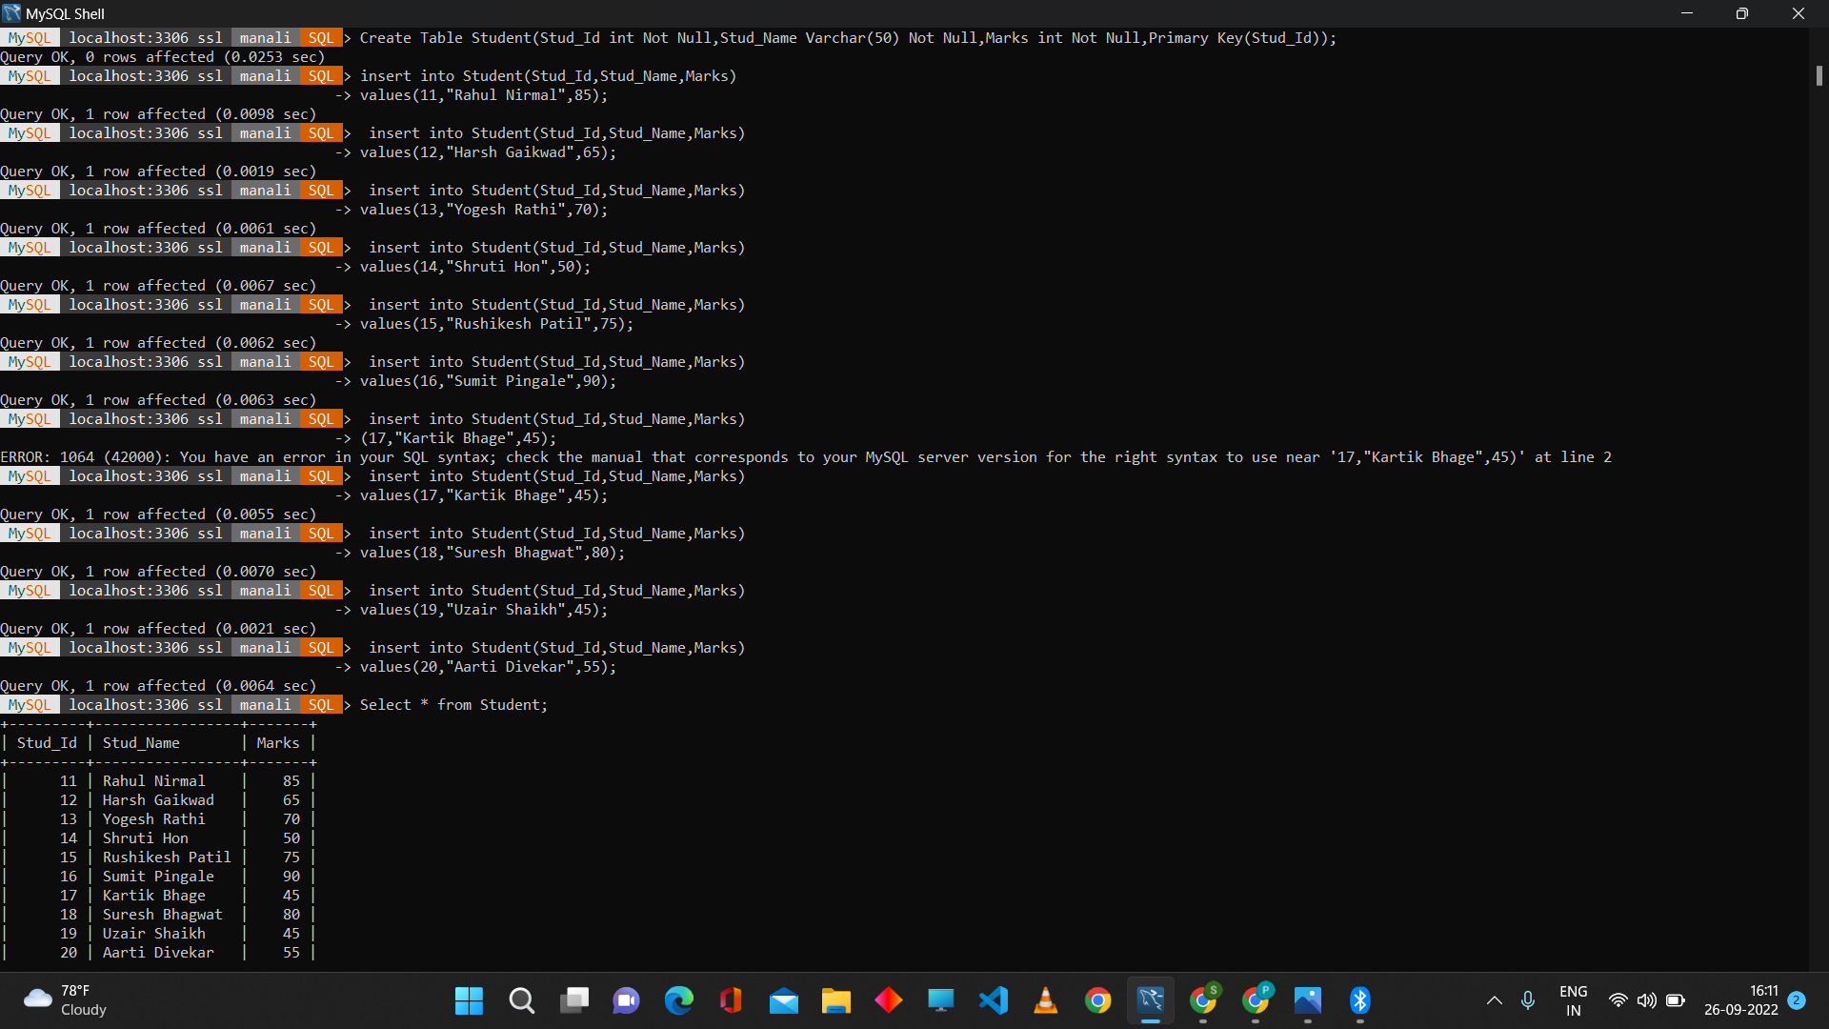

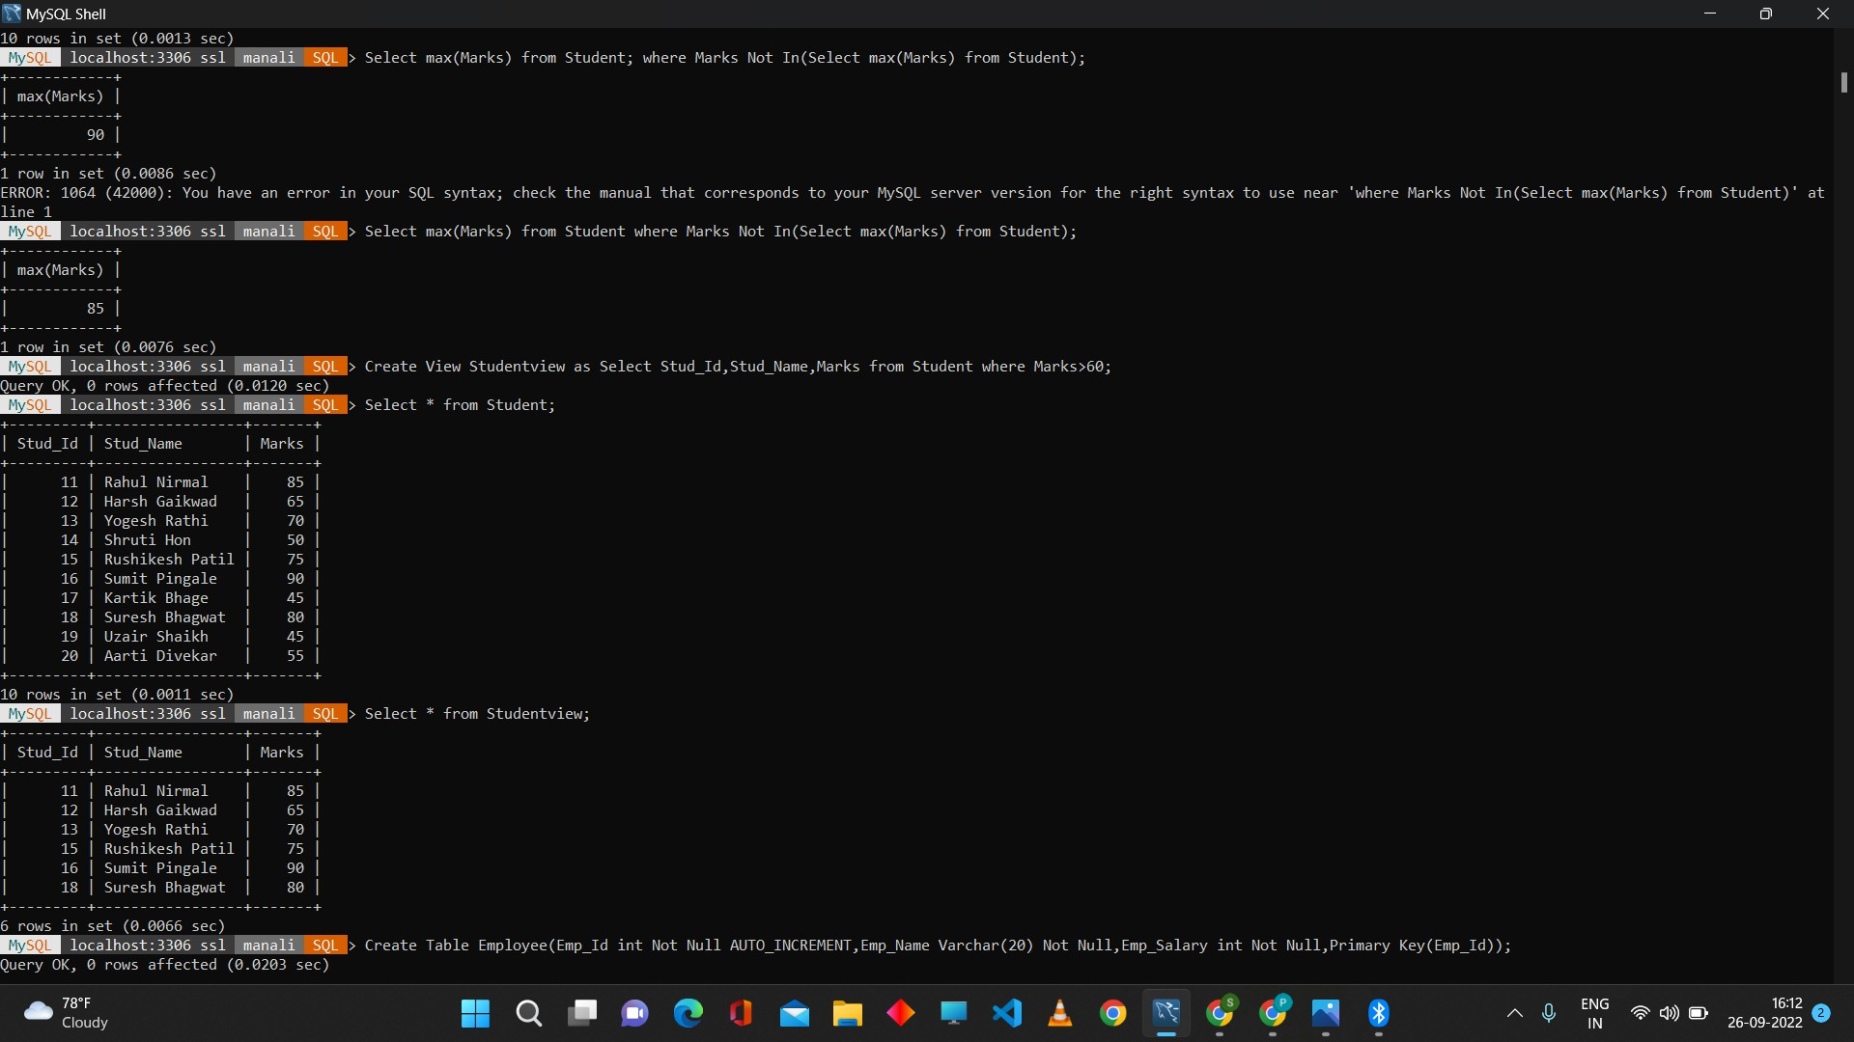

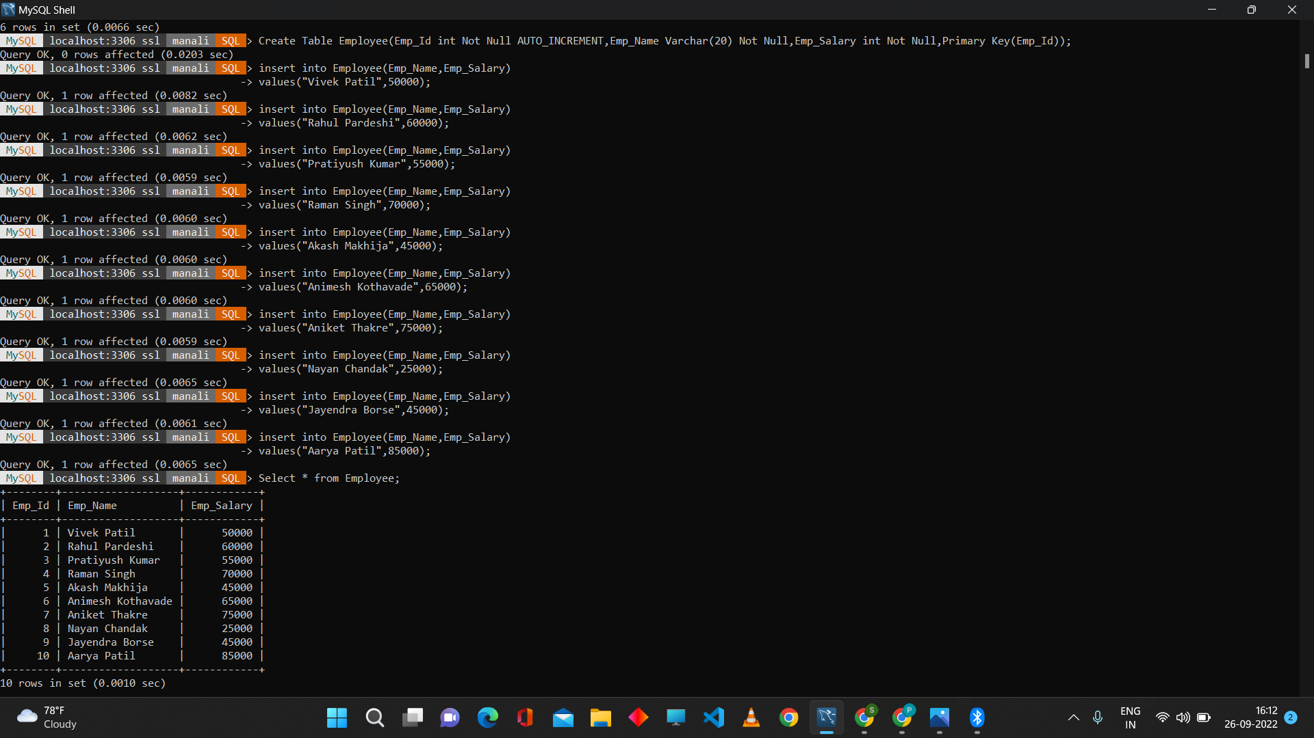

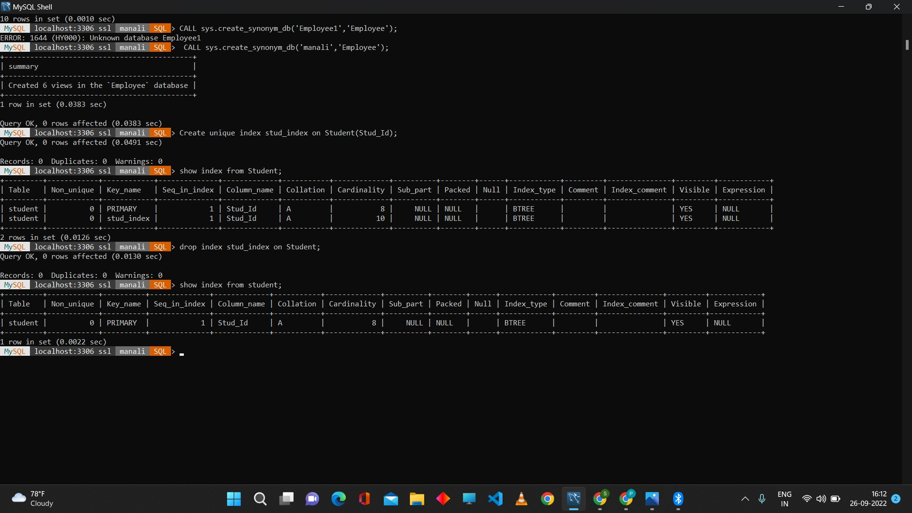

**Conclusion**: Thus, we have successfully written and executed join operations such as Inner Join, Left Join, Right Join, Full Join etc. Sub-query for second highest Marks and also created queries for VIEW, INDEX, SEQUENCE, SYNONYM.